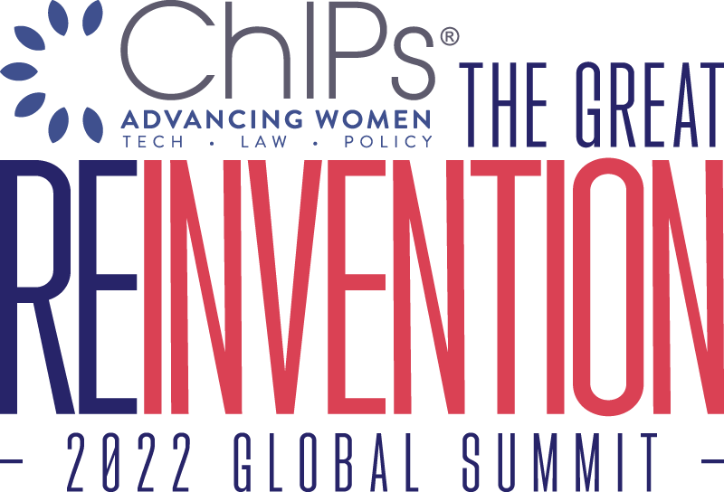

ChIPs Global Summit 2022
The Great Reinvention | October 26-28, 2022
Fairmont Hotel, San Francisco

Wednesday, October 26, 2022

The ChIPs Hall of Fame Awards Gala (separate ticket required)
6:30 – 9:00 PM
The Global Summit kicks off officially with the Hall of Fame dinner featuring a keynote speech and fireside chat with this year’s honoree, Mary Cranston in conversation with Dorian Daley, Executive Vice President and General Counsel, Oracle Corporation.

Ms. Cranston is Chair Emeritus of Pillsbury Winthrop Shaw Pittman LLP. She was elected to three successive terms as the Chair and CEO of the Global 100 law firm, which has 2,000 employees in 16 offices worldwide.

She is currently a member of the boards of VISA, Chemours, TPG Capital, and AAA Insurance. She has also served on the boards of McAfee, Myokardia, Juniper Networks, International Rectifier, Exponent, and Graftech International. In her various boards, she has been Lead Director, Audit Chair, Compensation Chair and Nominating and Governance Chair.

Learn more about Ms. Cranston and the ChIPs Hall of Fame.

6:30–7:20 pm Hosted reception
7:30 pm Dinner served
7:40–8:00 pm Awards presentation
8:30-9:00 pm Networking and coffee
8:30-9:00 pm Conversation with Mary Cranston

Thursday, October 27, 2022

Opening General Session

7:30 AM Reconnect: Networking Breakfast One hour

8:40 AM State of the ChIPs Union: Executive Director Joan Toth and Board Chair Katherine Minarik

9:00 AM Opening Fireside Chat: We are thrilled to welcome to the stage and open the Summit with a fireside chat as Amy Weaver, President and Chief Financial Officer of Salesforce is interviewed by Jennifer Yokoyama, ChIPs board member and Corporate Vice President and Deputy General Counsel at Microsoft.

Cyndi Wheeler, ChIPs board member and Senior Director of Intellectual Property at Salesforce will share opening remarks and introduce Amy Weaver and Jennifer Yokoyama to the stage.

10:00 AM Welcoming Scholarship Recipients: Please join us in honoring the 2022 ChIPs Scholarship Recipients for their interest in pursuing IP law and their commitment to advancing and connecting women in tech, law, and policy. Rachel Geiger, Santa Clara University School of Law, and Niki Camateros-Mann, University of New Hampshire, Franklin Pierce School of Law.
Introductions by Bita Rahebi, co-chair of the global IP Litigation Group and the cross-disciplinary Intellectual Property Group at Morrison Foerster.

10:20 AM Reconnect: Networking Break 45 minutes

Morning Breakout Sessions

11:10 AM Cognitive Capital: Activating Innovation to Strengthen Our Greatest Asset: Jennifer Zientz, Deputy Director of Programs and Head of Clinical Services, Center for Brain Health.

11:10 AM Crypto Basics: From DeFi to Web3 to Smart Contracts—What Lawyers Should Know About this Technology Today

Finance is the most developed segment of decentralized technologies. Other quickly developing areas will have an impact on the legal system. Decentralized technology lives at the intersection of developments in AI, IoT, data, finance and infrastructure. Join us for this expert panel featuring:
- Olga Mack, CEO of Parley Pro, lecturer at Berkeley Law, and author, Blockchain Value: Transforming Business Models, Society and Communities
- Hermine Wong, Head of Policy, Coinbase
- Kelly Hunsaker, Silicon Valley Managing Partner, Winston & Strawn LLP
12:00 PM Reconnect: Networking Lunch 70 minutes

Afternoon Breakout Sessions

1:10 PM Executive Leadership and Life Coaching: Coaching is a common denominator in the career trajectories of high achievers. Coaches bring new perspective and can help you make the decisions and connections required to move ahead. Join us for a panel discussion featuring insights from coaches and those who’ve benefited from coaching as they share how coaching can enhance your career.

- Michelle Banks, Senior Advisor, BarkerGilmore
- Jane Finette, Founder and Executive Director, The Women's Impact Alliance
- Angela Han, Lawyer and Life Coach
- In-house lawyer to be announced

1:10 PM Technology and Politics—Congressional Investigations and Tech Regulations: The tech industry is facing new threats of regulation. Listen as our panel explores political developments and their impact on public policy, coming privacy regulations for social media companies, and best strategies for navigating the future regulatory landscape. Antitrust and where IP is threatened

Afternoon General Session

2:10 PM Health Data Privacy in the Digital Age: The notion of health information privacy has evolved over time as the healthcare industry has embraced technology. The digitization of health data has created new challenges for those responsible for ensuring that information remains secure and private. Hear from experts on a range of the challenges including HIPAA, Dobbs and how to recognize and re-evaluate how health data is used, telemedicine, app developers and device browsing history, encryption, antitrust concerns and the EU government.
Normative ramifications of dobbs, does amazon give away data without a warrant? Now people will think about it

- Alex Reeve Givens, President & CEO, Center for Democracy and Technology
- Heather Deixler, partner, Latham & Watkins LLP

3:00 PM Reconnect: Networking Break 45 minutes

Afternoon General Session continued

3:50 PM Intellectual Property and Beauty: Hear an expert legal panel discuss how to use patents to protect innovation in the beauty industry. You’ll also learn how ingredient-disclosure requirements and other regulatory changes may cause companies to file more patents.

- Moderator, Naomi Birbach, partner at Goodwin
- Beauty industry panelists to be announced soon

4:40 PM ChIPs DEI Honor Roll Recognition
Opening comments and awards presented by Caren Ulrich Stacy, Founder & Chief Experimentation Officer at Diversity Lab and Cyndi Wheeler, ChIPs board member and Senior Director of Intellectual Property at Salesforce.

- Morgan Lewis and Nixon Peabody have been recognized for Excellence in Inclusion for All.
- Orrick, Perkins Coie, and WilmerHale have been recognized for Excellence in Gender Inclusion.
- Read more here.

5:00 PM Access, Equity, and Allies: Across the legal industry efforts are being made to increase diversity in the pipeline, advance diversity at the top, and engage in equity across pay and promotions so everyone can have the opportunity to thrive at work. Panelists will share their insights on the challenges creating a diverse pipeline of lawyers, what is working, and action you can take to make meaningful change within your organization.

- Speakers to be announced soon.

Friday, October 28, 2022

7:30 AM Reconnect: Networking Breakfast One hour

8:35 AM Opening keynote—Kathi Vidal, Under Secretary of Commerce for Intellectual Property and Director of the United States Patent and Trademark Office: Don’t miss our opening keynote as the federal government’s top IP officer is interviewed by Sarita Venkat, ChIPs board member and Vice President and Deputy General Counsel of Global Litigation at Cisco.

9:35 AM IP and Entertainment: The hottest legal issues in Entertainment Tech: Learn about the latest developments from Apple TV, Netflix, Amazon Prime, and music streaming services like Pandora, Spotify, Sonos and more, in this leading-edge panel discussion.

- Stephanie Burns, Senior Vice President & General Counsel, Sony Interactive Entertainment
- Kelly Jo Macarthur, Vice President and Associate General Counsel, Global Media & Entertainment at Amazon

10:25 AM Reconnect: Networking Break 45 minutes

11:15 AM Hot Topics in IP Law Presented by Kirkland

12:10 PM Judicial Perspectives and Trends in Intellectual Property

- Hon. Yvonne Gonzalez Rogers, District Judge, United States District Court, Northern District of California
- Hon. Christa Zado, Administrative Patent Judge, Patent Trial and Appeal Board, U.S. Patent and Trademark Office
- Juanita Brooks, Principal and IP Trial Attorney, Fish & Richardson
- Natalie Alfaro Gonzales, Partner, Baker Botts, to introduce the panel

1:00 PM Closing Remarks

1:05 PM Reconnect: Lunch

Agenda as of 8/9/22, subject to change

