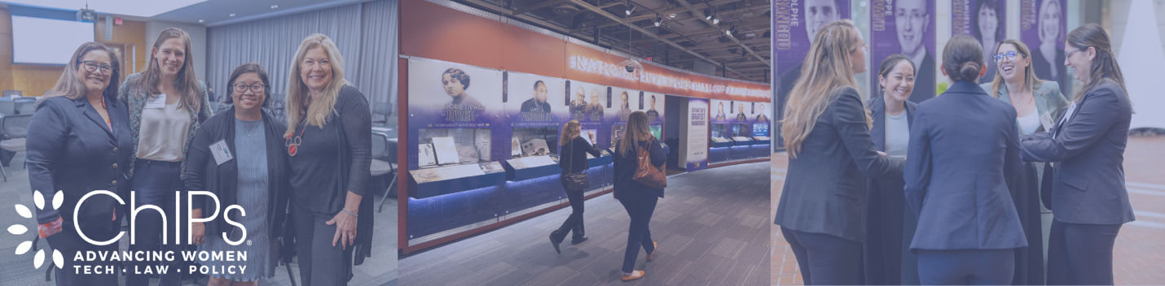
JUNE 6, 2024 | ORACLE | REDWOOD CITY, CA
TO: Your Supervisor
FROM: Your Name
SUBJECT: Request to Attend ChIPs NextGen Summit
Dear _____________,
I would like your approval to attend the ChIPs NextGen Summit 2024, Thursday, June 4 at the Oracle Office in Redwood City, California.
NextGen Summit is the premiere event for rising women stars in tech law, innovation and government -- produced by ChIPs, the industry’s leading global network for women. It can benefit me, our team and our entire organization:
- Skill-building sessions where I’ll earn CLE credits (pending) and share this knowledge with my colleagues.
- New business connections — I will meet lawyers, practitioners and professionals from all sectors of tech and IP.
- Learn from leaders — and peers. I’ll get experience from industry leaders and advice from my peers.
- Last but not least — the ChIPs NextGen Summit will raise our firm’s profile and showcase our commitment to women and diversity.
ChIPs NextGen Summit is cost-effective. The all-inclusive fee of $495 includes breakfast, breaks, luncheon and closing reception. Thank you in advance for your approval.
Sincerely,
Your Name

